Circular Cylindrical Surface

Definition
# Source: AI Source: Provided by: [Data Path: Persons Table -> ID Column: 1, Name_En Column: Motasem Essam] -> From: [ChatGPT] on [7/20/2026]
A Circular Cylindrical Surface is a cylindrical surface whose directrix is a circle.
It is generated by moving a straight line, called a generator, parallel to a fixed direction while its endpoint follows a circular curve.
In the standard case, the generators are parallel to the axis of the cylinder, producing the familiar curved surface associated with a circular cylinder.
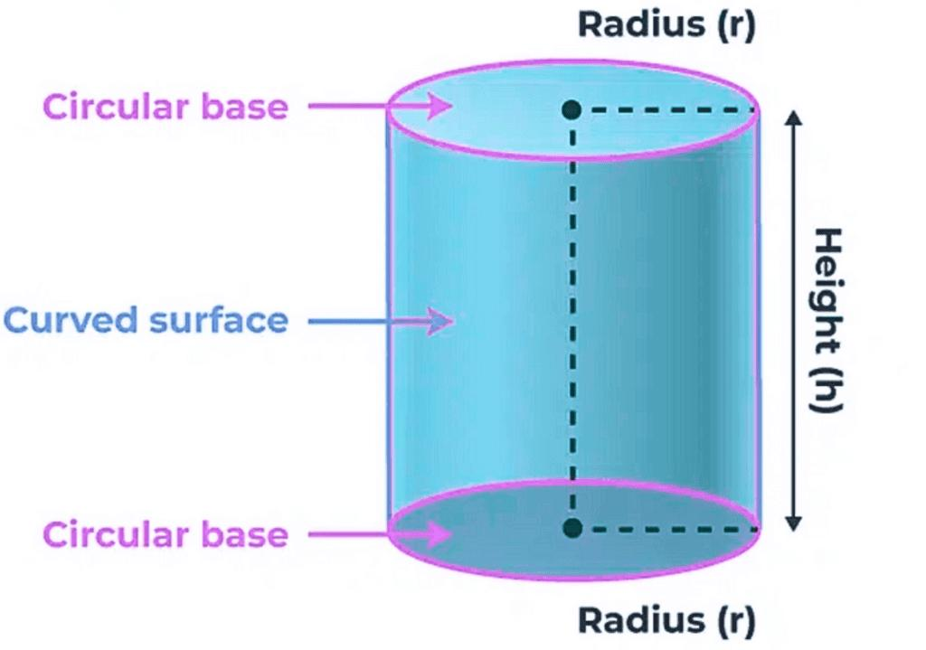
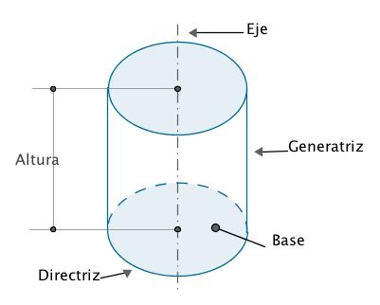
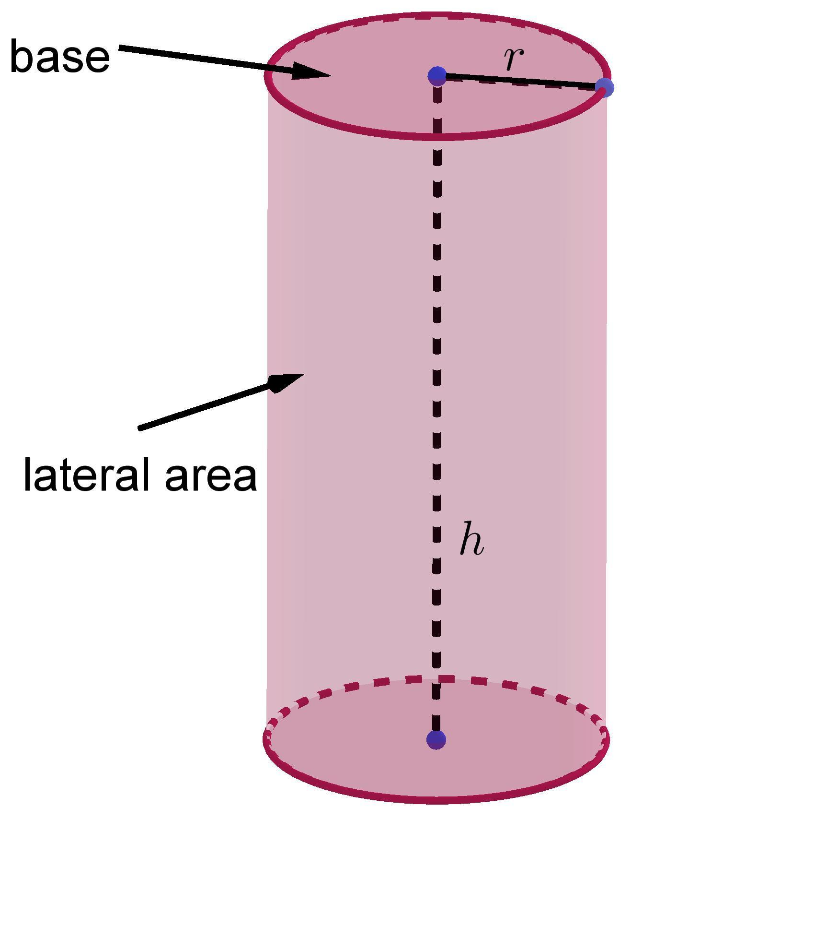
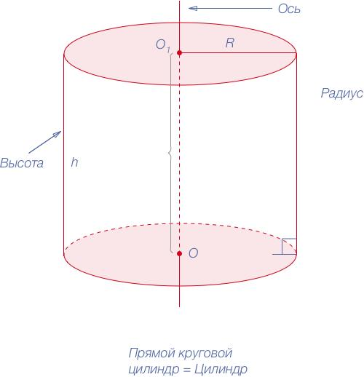
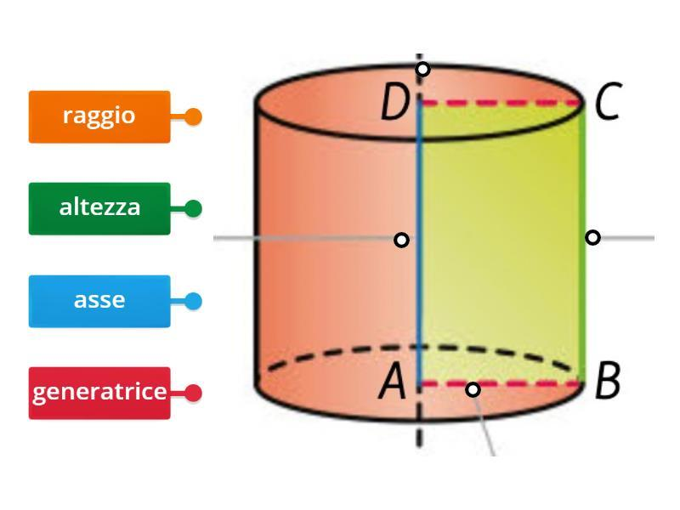

Purpose
# Source: AI Source: Provided by: [Data Path: Persons Table -> ID Column: 1, Name_En Column: Motasem Essam] -> From: [ChatGPT] on [7/20/2026]
A circular cylindrical surface is used to:
- Describe the curved surface of a circular cylinder.
- Calculate curved surface area.
- Model cylindrical objects in three-dimensional geometry.
- Study surfaces generated by parallel straight lines.
- Connect geometric surfaces with coordinate equations.
- Model pipes, tubes, tanks, columns, shafts, and rollers.

Fundamental Elements
# Source: AI Source: Provided by: [Data Path: Persons Table -> ID Column: 1, Name_En Column: Motasem Essam] -> From: [ChatGPT] on [7/20/2026]
A circular cylindrical surface has several important elements.

1. Directrix
# Source: AI Source: Provided by: [Data Path: Persons Table -> ID Column: 1, Name_En Column: Motasem Essam] -> From: [ChatGPT] on [7/20/2026]
The directrix is the fixed circular curve that determines the shape of the cylindrical surface.
For a circular cylindrical surface, the directrix is:
$$\boxed{\text{Circle}}$$

2. Generator
# Source: AI Source: Provided by: [Data Path: Persons Table -> ID Column: 1, Name_En Column: Motasem Essam] -> From: [ChatGPT] on [7/20/2026]
A generator is a straight line that moves parallel to a fixed direction while its endpoint traces the directrix.
For a right circular cylindrical surface, the generators are parallel to the axis.

3. Axis
# Source: AI Source: Provided by: [Data Path: Persons Table -> ID Column: 1, Name_En Column: Motasem Essam] -> From: [ChatGPT] on [7/20/2026]
The axis is the central straight line associated with the circular cylindrical surface.
For a right circular cylinder, it passes through the centers of the circular cross-sections.

4. Radius
# Source: AI Source: Provided by: [Data Path: Persons Table -> ID Column: 1, Name_En Column: Motasem Essam] -> From: [ChatGPT] on [7/20/2026]
The radius $r$is the distance from the axis to the cylindrical surface.

5. Height
# Source: AI Source: Provided by: [Data Path: Persons Table -> ID Column: 1, Name_En Column: Motasem Essam] -> From: [ChatGPT] on [7/20/2026]
For a finite cylindrical surface, the height $h$is the distance measured parallel to the axis between the two circular boundary curves.

Mathematical Representation
# Source: AI Source: Provided by: [Data Path: Persons Table -> ID Column: 1, Name_En Column: Motasem Essam] -> From: [ChatGPT] on [7/20/2026]
Consider a circular cylindrical surface whose axis is the $z$-axis.
Its equation is:
$$\boxed{x^{2}+y^{2}=r^{2}}$$
For a finite cylindrical surface with height $h$:
$$\boxed{x^{2}+y^{2}=r^{2}, 0≤z≤h}$$
The equation means that every point on the surface has a constant distance $r$from the $z$-axis.
The distance from a point $\left(x , y , z\right)$to the $z$-axis is:
$$\sqrt{x^{2}+y^{2}}$$
Therefore:
$$\sqrt{x^{2}+y^{2}}=r$$
and squaring gives:
$$x^{2}+y^{2}=r^{2}$$

Parametric Representation
# Source: AI Source: Provided by: [Data Path: Persons Table -> ID Column: 1, Name_En Column: Motasem Essam] -> From: [ChatGPT] on [7/20/2026]
A circular cylindrical surface can also be represented parametrically:
$$x=r\cos{θ} \\ y=r\sin{θ} \\ z=z$$
where:
$$0≤θ<2π$$
and $z$varies along the height.
For a finite cylinder:
$$0≤z≤h$$
This representation makes the circular nature of the surface explicit.

Curved Surface Area
# Source: AI Source: Provided by: [Data Path: Persons Table -> ID Column: 1, Name_En Column: Motasem Essam] -> From: [ChatGPT] on [7/20/2026]
For a finite circular cylindrical surface, the curved surface area is:
$$\boxed{CSA=2πrh}$$
where:
- $r$= radius
- $h$= height
This represents only the curved lateral surface.
The two circular bases are not included.
Total Surface Area
If the two circular bases are included:
$$\boxed{TSA=2πrh+2πr^{2}}$$
or:
$$\boxed{TSA=2πr\left(h+r\right)}$$

Development of a Circular Cylindrical Surface
# Source: AI Source: Provided by: [Data Path: Persons Table -> ID Column: 1, Name_En Column: Motasem Essam] -> From: [ChatGPT] on [7/20/2026]
If the cylindrical surface is cut along one generator and unfolded, it becomes a rectangle.
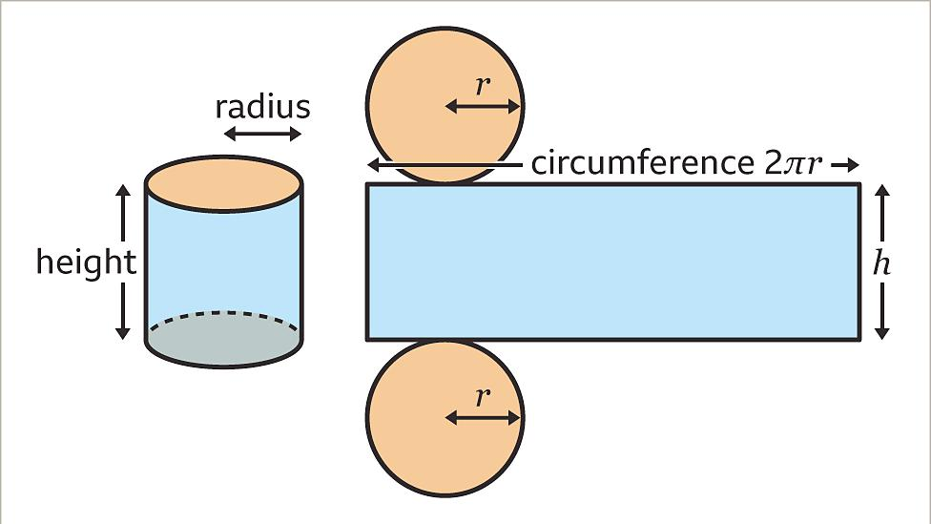
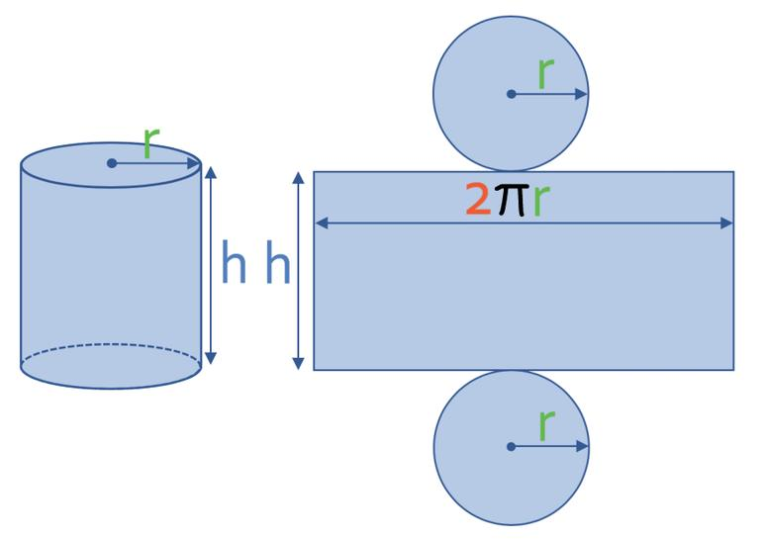
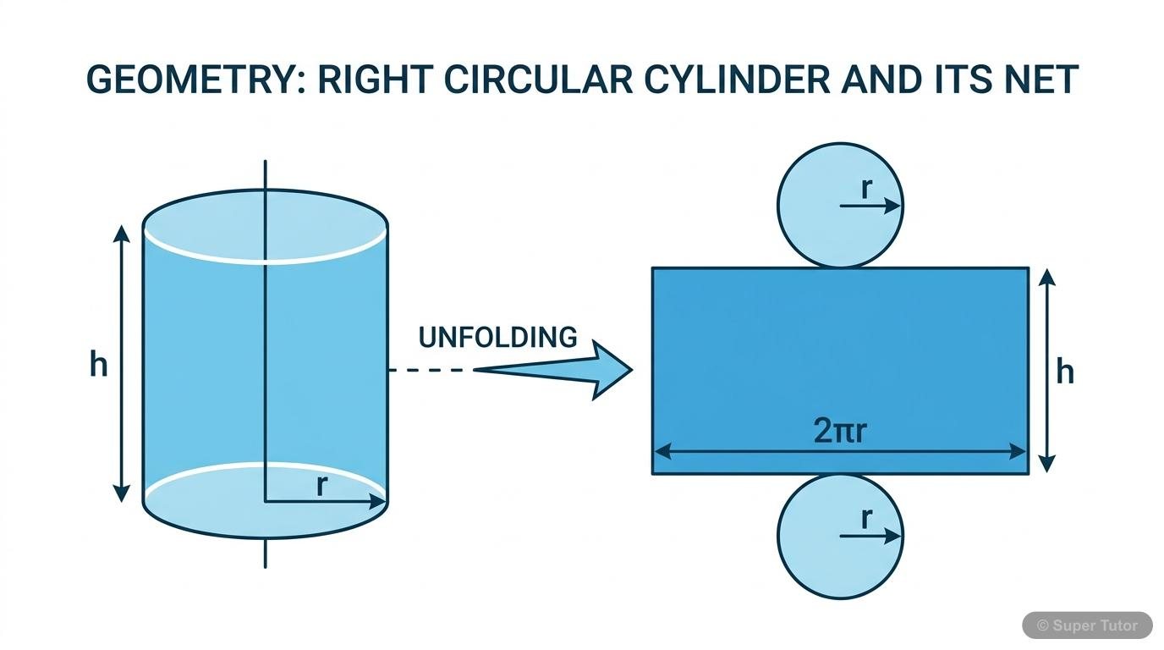
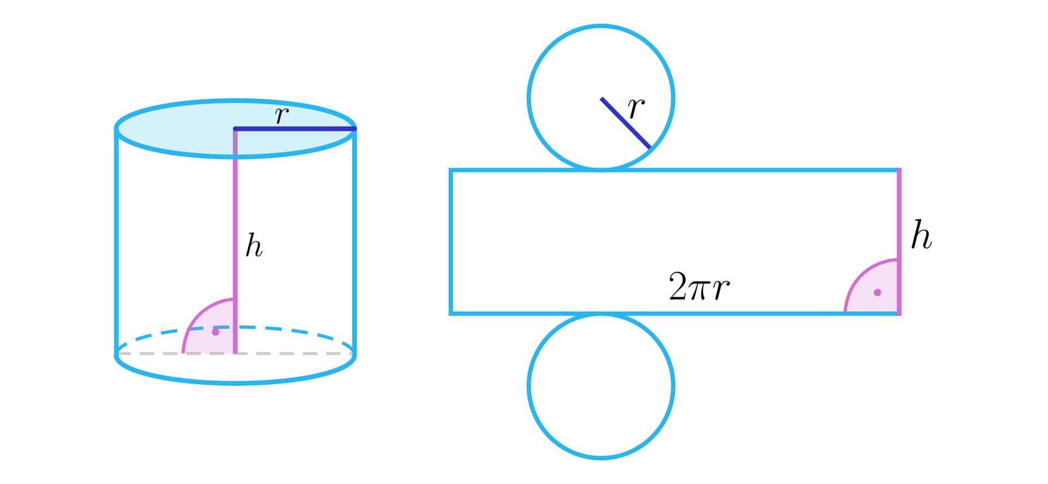
The rectangle has:
$$\text{Width}=2πr$$
and:
$$\text{Height}=h$$
Therefore:
$$A=\left(2πr\right)h$$
so:
$$\boxed{A=2πrh}$$
This is why the curved surface area of a circular cylinder is the same as the area of the rectangle obtained by unfolding it.

Main Properties
# Source: AI Source: Provided by: [Data Path: Persons Table -> ID Column: 1, Name_En Column: Motasem Essam] -> From: [ChatGPT] on [7/20/2026]
A circular cylindrical surface has the following properties:
- It is a curved surface.
- Its directrix is a circle.
- Its generators are straight lines.
- In a right circular cylindrical surface, the generators are parallel to the axis.
- Every point on the surface is at a constant perpendicular distance $r$from the axis.
- A finite lateral circular cylindrical surface has two circular boundary curves.
- It has no vertices.
- It has no sharp edges along its curved portion.
- Its curvature is zero in the direction parallel to the axis.
- Its curvature is nonzero in the direction around the cylinder.
- Its curved surface area is:
$$\boxed{2πrh}$$
- A finite lateral circular cylindrical surface is an open surface.

Right Circular vs Oblique Circular Cylindrical Surface
# Source: AI Source: Provided by: [Data Path: Persons Table -> ID Column: 1, Name_En Column: Motasem Essam] -> From: [ChatGPT] on [7/20/2026]
A circular cylindrical surface can be further classified according to the relationship between its generators and its circular cross-sections.
Right Circular Cylindrical Surface
The generators are perpendicular to the circular bases.
The axis is perpendicular to the bases.
Oblique Circular Cylindrical Surface
The generators are inclined relative to the perpendicular direction of the circular bases.
The axis is not perpendicular to the bases.
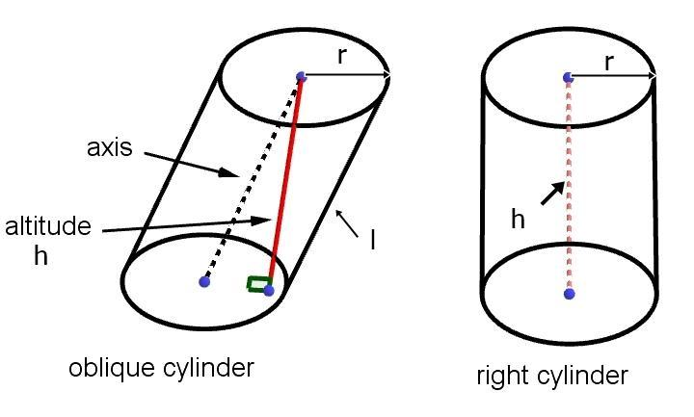
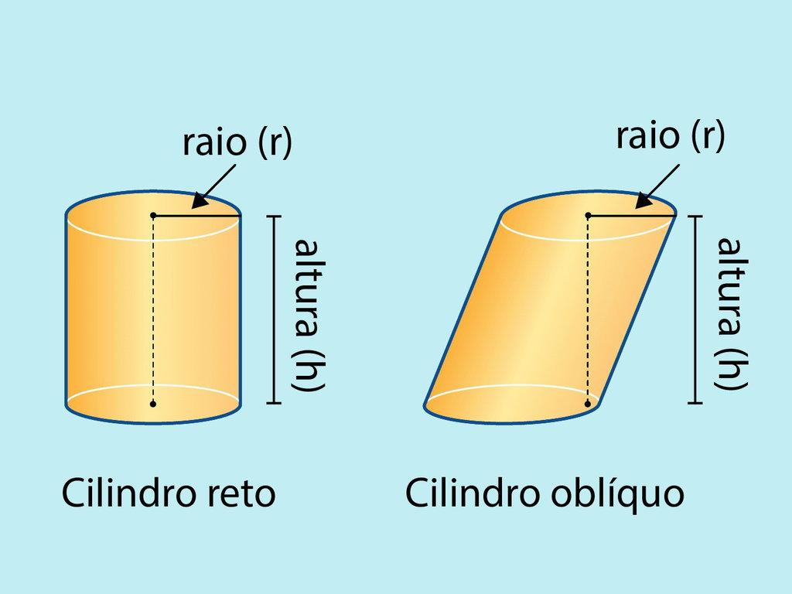
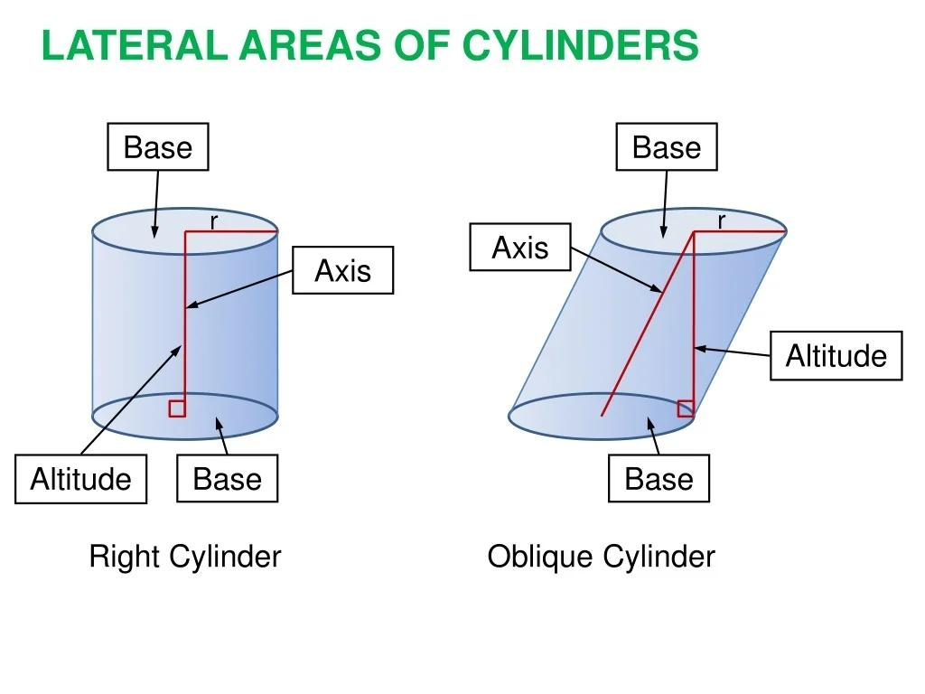

Open and Closed Circular Cylindrical Surfaces
# Source: AI Source: Provided by: [Data Path: Persons Table -> ID Column: 1, Name_En Column: Motasem Essam] -> From: [ChatGPT] on [7/20/2026]
The terms circular, open, and closed describe different properties.
Circular Cylindrical Lateral Surface
The curved part without the bases is:
$$\boxed{\text{Circular}+\text{Curved}+\text{Open}}$$
It has two circular boundary curves.
Complete Circular Cylindrical Surface
If the two circular bases are added, the surface completely encloses the cylindrical solid:
$$\boxed{\text{Circular}+\text{Curved/Flat}+\text{Closed}}$$
The complete boundary consists of:
- One curved cylindrical surface
- Two circular plane surfaces
This illustrates that geometric form and boundary classification are independent.

Examples

Example 1: Finding Curved Surface Area
# Source: AI Source: Provided by: [Data Path: Persons Table -> ID Column: 1, Name_En Column: Motasem Essam] -> From: [ChatGPT] on [7/20/2026]
A circular cylindrical surface has:
$$r=4\text{ cm}$$
and:
$$h=10\text{ cm}$$
Using:
$$CSA=2πrh \\ CSA=2π\left(4\right)\left(10\right) \\ \boxed{CSA=80π{\text{ cm}}^{2}}$$
Approximately:
$$\boxed{CSA≈251.33{\text{ cm}}^{2}}$$

Example 2: Finding the Radius
# Source: AI Source: Provided by: [Data Path: Persons Table -> ID Column: 1, Name_En Column: Motasem Essam] -> From: [ChatGPT] on [7/20/2026]
Suppose:
$$CSA=100π{\text{ cm}}^{2}$$
and:
$$h=10\text{ cm}$$
Using:
$$100π=2πrh \\ 100π=2πr\left(10\right) \\ 100π=20πr$$
Therefore:
$$\boxed{r=5\text{ cm}}$$

Example 3: Finding the Height
# Source: AI Source: Provided by: [Data Path: Persons Table -> ID Column: 1, Name_En Column: Motasem Essam] -> From: [ChatGPT] on [7/20/2026]
Suppose:
$$CSA=120π{\text{ cm}}^{2}$$
and:
$$r=6\text{ cm}$$
Then:
$$120π=2π\left(6\right)h \\ 120π=12πh \\ h=10$$
Therefore:
$$\boxed{h=10\text{ cm}}$$

Relationship with the Circle
# Source: AI Source: Provided by: [Data Path: Persons Table -> ID Column: 1, Name_En Column: Motasem Essam] -> From: [ChatGPT] on [7/20/2026]
A circular cylindrical surface is directly related to the circle.
A horizontal cross-section perpendicular to the axis produces a circle:
$$\boxed{x^{2}+y^{2}=r^{2}}$$
Thus:
$$\text{Circle}+\text{Parallel Translation}⟶\text{Circular Cylindrical Surface}$$
Alternatively, the surface can be understood as the result of translating a circle along a direction perpendicular to its plane.

Circular Cylindrical Surface vs General Cylindrical Surface
# Source: AI Source: Provided by: [Data Path: Persons Table -> ID Column: 1, Name_En Column: Motasem Essam] -> From: [ChatGPT] on [7/20/2026]
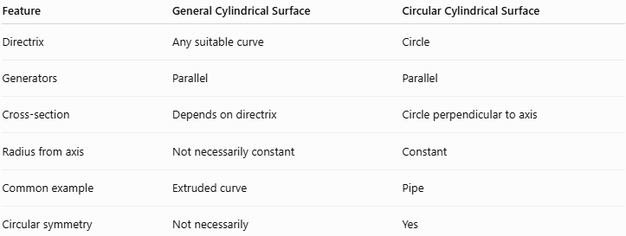
Feature | General Cylindrical Surface | Circular Cylindrical Surface
Directrix | Any suitable curve | Circle
Generators | Parallel | Parallel
Cross-section | Depends on directrix | Circle perpendicular to axis
Radius from axis | Not necessarily constant | Constant
Common example | Extruded curve | Pipe
Circular symmetry | Not necessarily | Yes
Therefore:
$$\boxed{\text{Circular Cylindrical Surface}⊂\text{Cylindrical Surfaces}}$$

Circular Cylindrical Surface vs Conical Surface
# Source: AI Source: Provided by: [Data Path: Persons Table -> ID Column: 1, Name_En Column: Motasem Essam] -> From: [ChatGPT] on [7/20/2026]
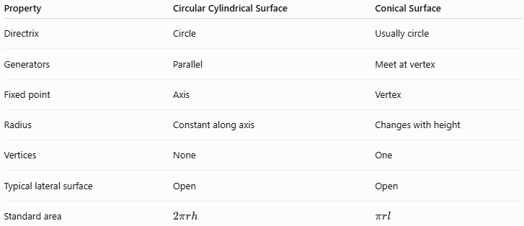
Property | Circular Cylindrical Surface | Conical Surface
Directrix | Circle | Usually circle
Generators | Parallel | Meet at vertex
Fixed point | Axis | Vertex
Radius | Constant along axis | Changes with height
Vertices | None | One
Typical lateral surface | Open | Open
Standard area | $$2πrh$$ | $$πrl$$
The fundamental difference is:
$$\boxed{\text{Cylindrical generators are parallel}}$$
while:
$$\boxed{\text{Conical generators meet at a common vertex}}$$

Real-World Applications
# Source: AI Source: Provided by: [Data Path: Persons Table -> ID Column: 1, Name_En Column: Motasem Essam] -> From: [ChatGPT] on [7/20/2026]
Circular cylindrical surfaces are found in:
- Pipes
- Water tanks
- Metal cans
- Bottles
- Columns
- Shafts
- Rollers
- Barrels
- Storage tanks
- Tubes
- Cylindrical buildings
- Machine components
For example, when determining the amount of sheet metal required to cover the curved outside of a cylindrical tank, the circular cylindrical surface area is used.

Advantages
# Source: AI Source: Provided by: [Data Path: Persons Table -> ID Column: 1, Name_En Column: Motasem Essam] -> From: [ChatGPT] on [7/20/2026]
- Simple geometric structure.
- Easy mathematical representation.
- Straightforward surface-area formula.
- Can be unfolded into a rectangle.
- Useful for modeling many manufactured objects.
- Has strong rotational symmetry.
- Easily represented using Cartesian and parametric equations.

Limitations
# Source: AI Source: Provided by: [Data Path: Persons Table -> ID Column: 1, Name_En Column: Motasem Essam] -> From: [ChatGPT] on [7/20/2026]
- The formula $2πrh$describes the lateral surface of a circular cylinder.
- The circular bases are not included in curved surface area.
- The standard equation $x^{2}+y^{2}=r^{2}$assumes an axis aligned with the $z$-axis.
- More complicated orientations require coordinate transformations.
- Real cylindrical objects may have irregularities or non-circular cross-sections.

Key Points
# Source: AI Source: Provided by: [Data Path: Persons Table -> ID Column: 1, Name_En Column: Motasem Essam] -> From: [ChatGPT] on [7/20/2026]
- A Circular Cylindrical Surface is a cylindrical surface whose directrix is a circle.
- It is generated by parallel straight lines called generators.
- A standard circular cylindrical surface has a constant radius from its axis.
- Its equation, when the axis is the $z$-axis, is:
$$\boxed{x^{2}+y^{2}=r^{2}}$$
- For a finite lateral surface:
$$\boxed{x^{2}+y^{2}=r^{2}, 0≤z≤h}$$
- Its curved surface area is:
$$\boxed{CSA=2πrh}$$
- The lateral surface is open.
- Adding the two circular bases produces a closed cylindrical surface.
- Circular cylindrical surfaces can be right or oblique.
- A circular cylindrical surface is a specific type of cylindrical surface:
$$\boxed{\text{Circular Cylindrical Surface}⊂\text{Cylindrical Surface}}$$

Conclusion
# Source: AI Source: Provided by: [Data Path: Persons Table -> ID Column: 1, Name_En Column: Motasem Essam] -> From: [ChatGPT] on [7/20/2026]
A Circular Cylindrical Surface is a specific type of cylindrical surface generated from a circular directrix and parallel generators. It is one of the most important curved surfaces in elementary three-dimensional geometry because of its simple structure and its many practical applications.
For a standard circular cylindrical surface, the defining equation is:
$$\boxed{x^{2}+y^{2}=r^{2}}$$
and the curved surface area of a finite right circular cylinder is:
$$\boxed{CSA=2πrh}$$
In your surface taxonomy, it should therefore be organized as:
$$\boxed{\text{Surface}→\text{Curved Surface}→\text{Cylindrical Surface}→\text{Circular Cylindrical Surface}}$$
with Right Circular and Oblique Circular Cylindrical Surfaces treated as further classifications.

